DAY 3

Q5 (User Inputs, Operations & Output)
📋
Write a program to convert temperature from Celsius to Fahrenheit.
Show Sample Test Cases

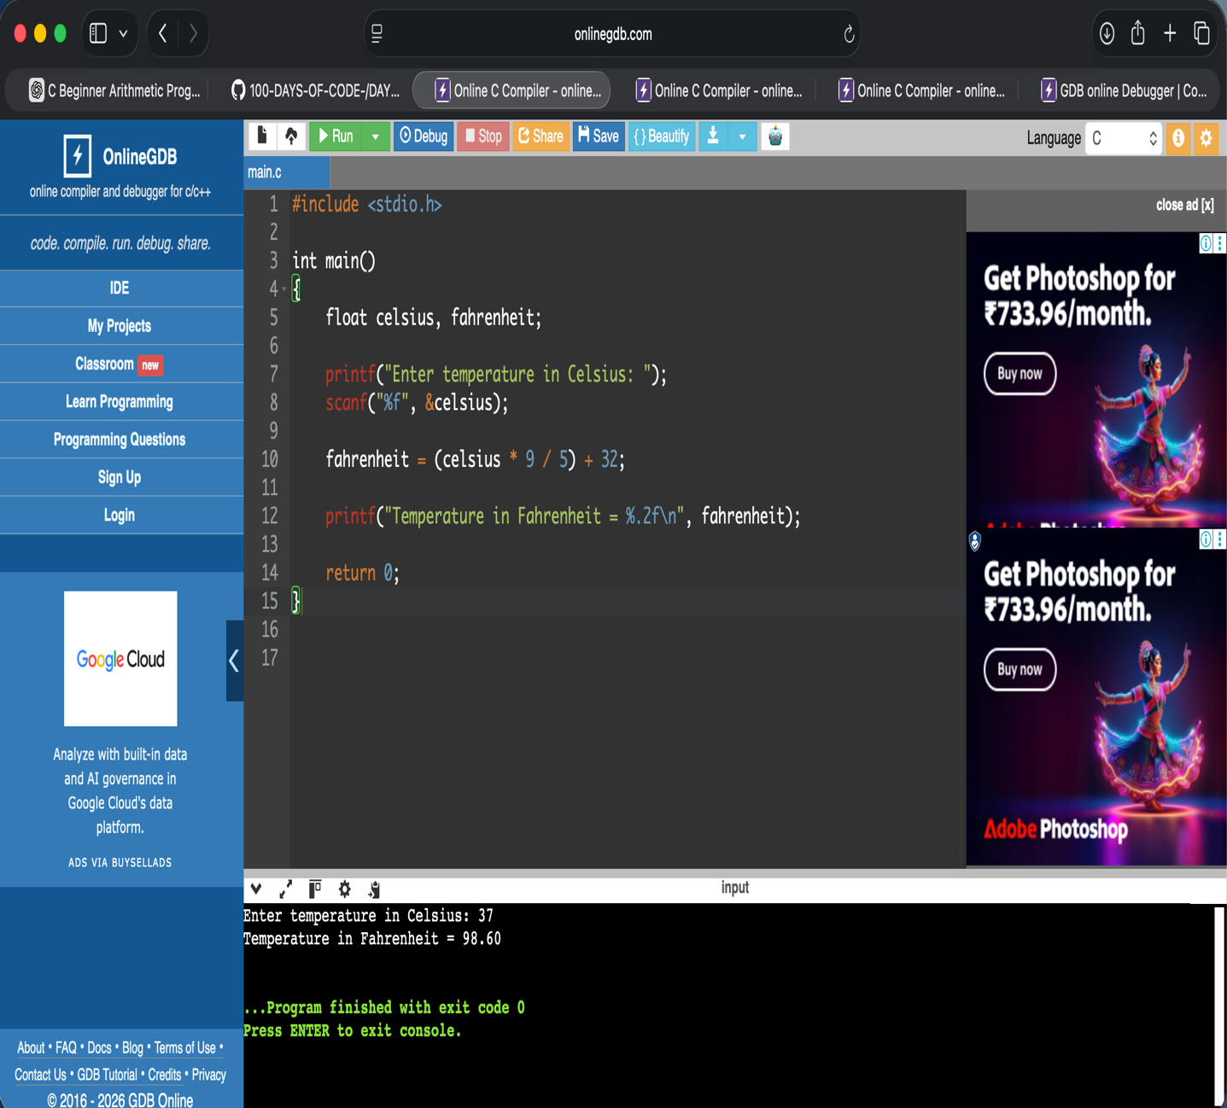

Q6 (User Inputs, Operations & Output)
📋
Write a program to swap two numbers using a third variable.
Show Sample Test Cases

